Mogul in the Making

1. **Logging In**

The user will find us on the home page as its own tile called “Mogul in the Making”. It would be included in the below screen when fully done.

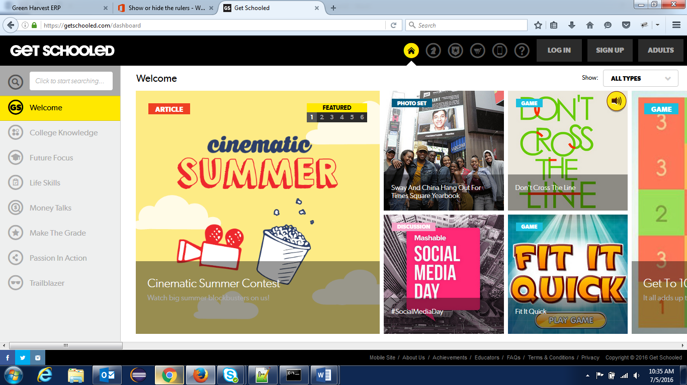

It will prompt them to login in the following screen.

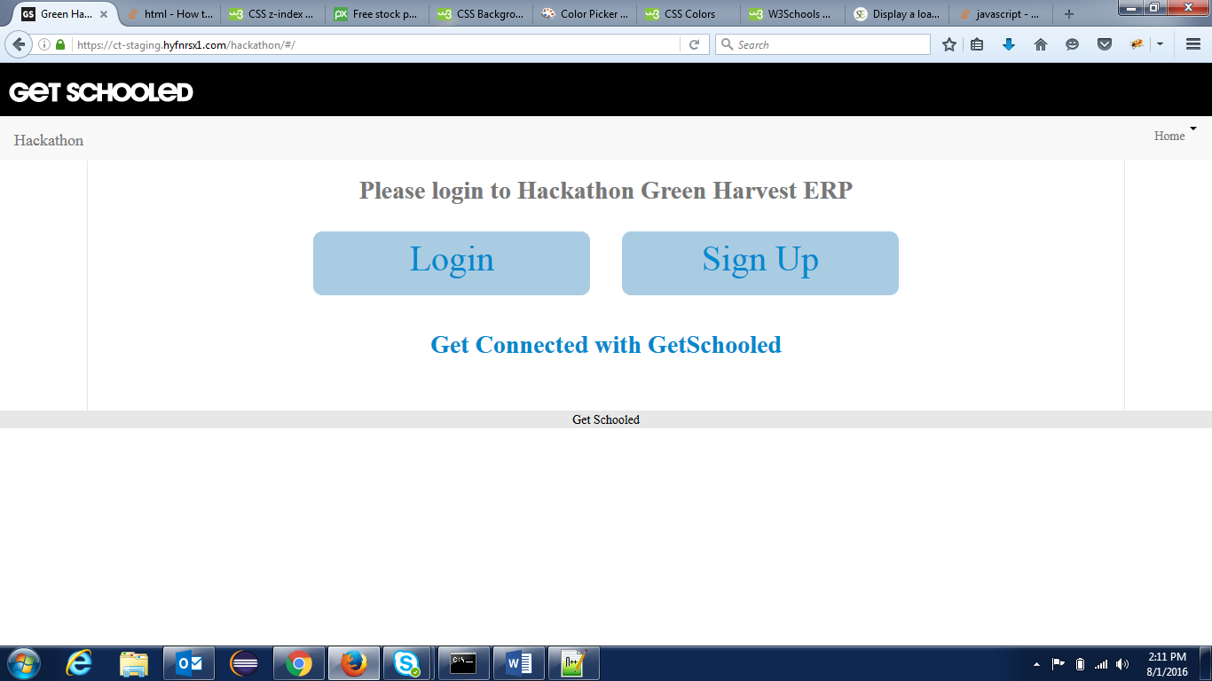

Click the “Get Connected with GetSchooled” link which will take you to a login. After logging in, the user will be brought to the home screen. It will be a list of all the business idea submissions the user has completed.

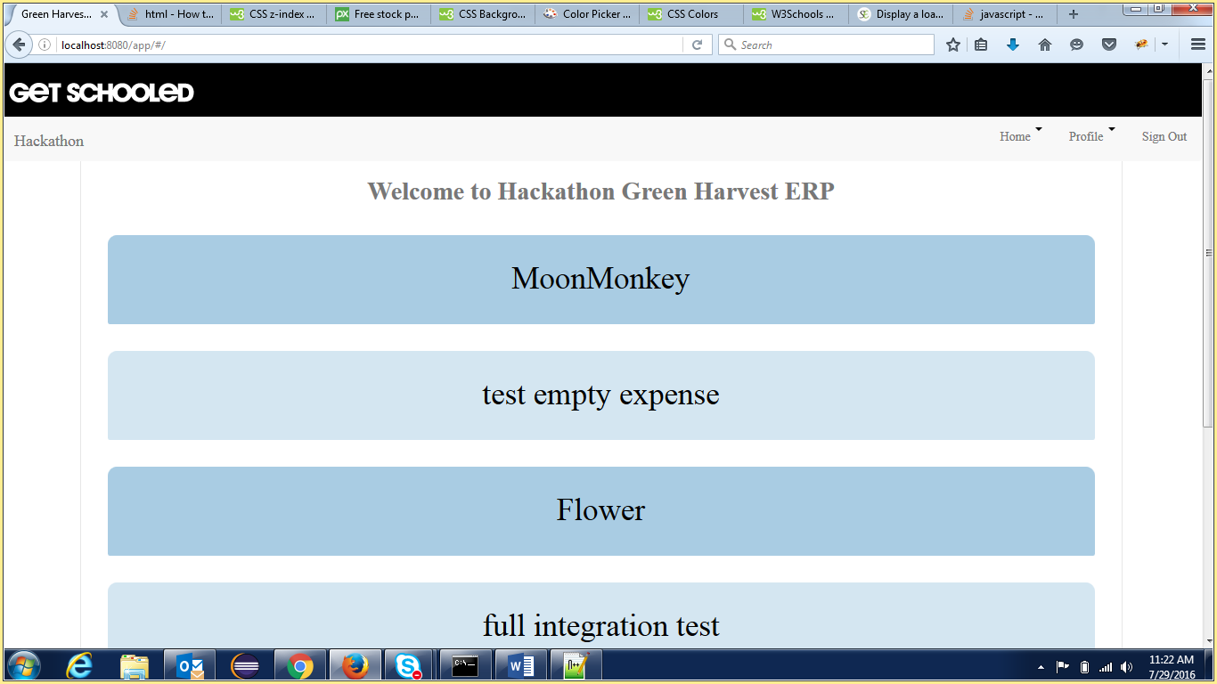

1. **Submitting a Business Proposal**

When the user wants to submit a business proposal, they either click on the Profile button along the top navigation, or click the plus button on the bottom of the page.

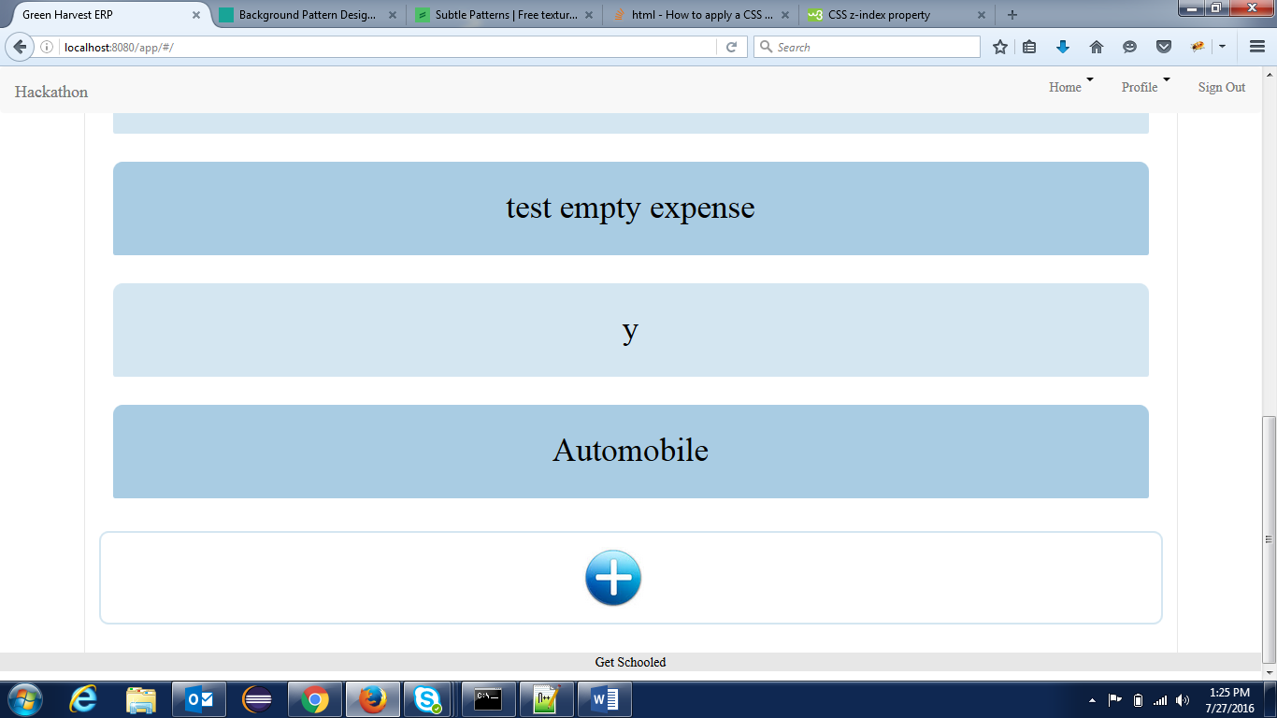

This will bring them to the submission form. There are 2 parts to the submission form. Part one is submitting the business idea with information on the name, basic overview of the idea, industry, sub-industry, and a more in depth description.

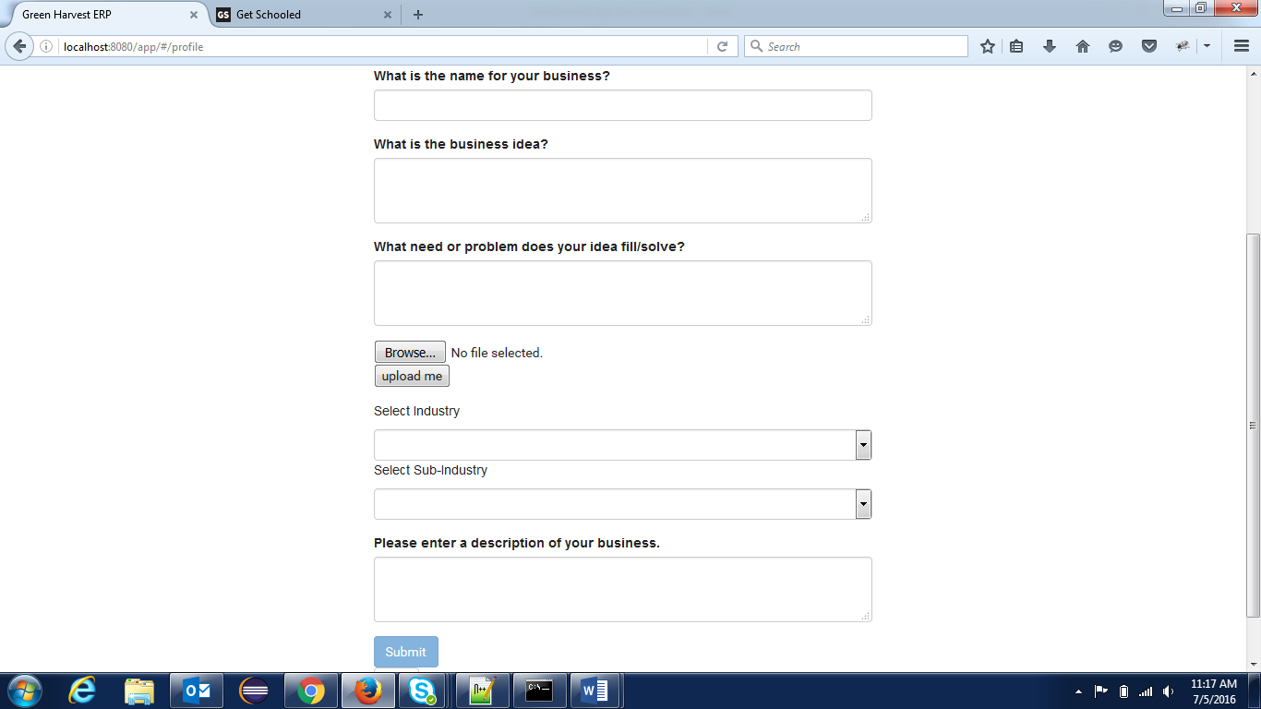

Information on Inputs:

Name of Business: Short text input

Business Idea: Long text input

Problem Being Solved: Long text input

Industry: Drop down list

Sub Industry: Drop down list, dependent on Industry selection

Description of Business: Long text input

There is a popup box with information on how many points you earned submitting the business idea and whether you want to continue to part two now or later. You can select “Save & Exit” to return to the home page and continue to part two at a different time.

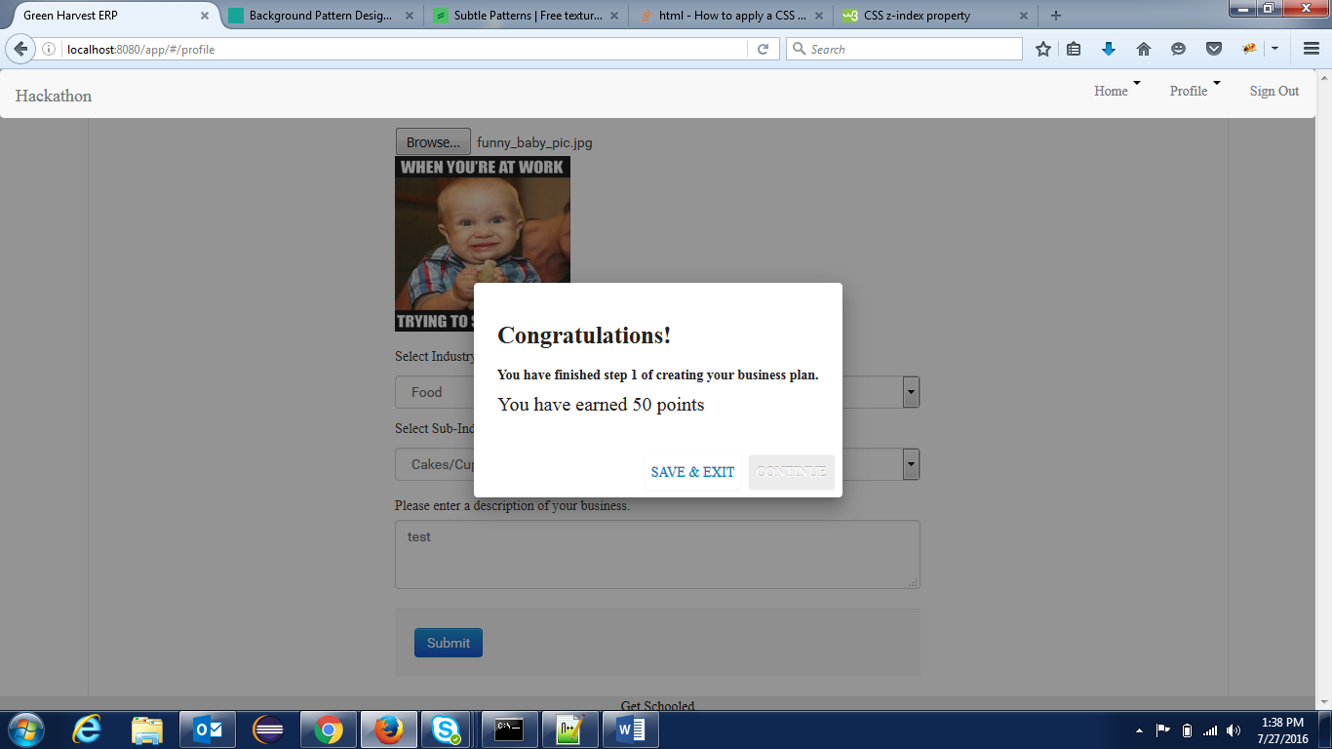

Part two is submitting the business plan and it is broken into three categories: Market, Expenses, and Promotion. Market covers information about the target market, expenses covers information on the cost of running the business, and promotion covers information on how the user plans on promoting the product to reach his potential market.

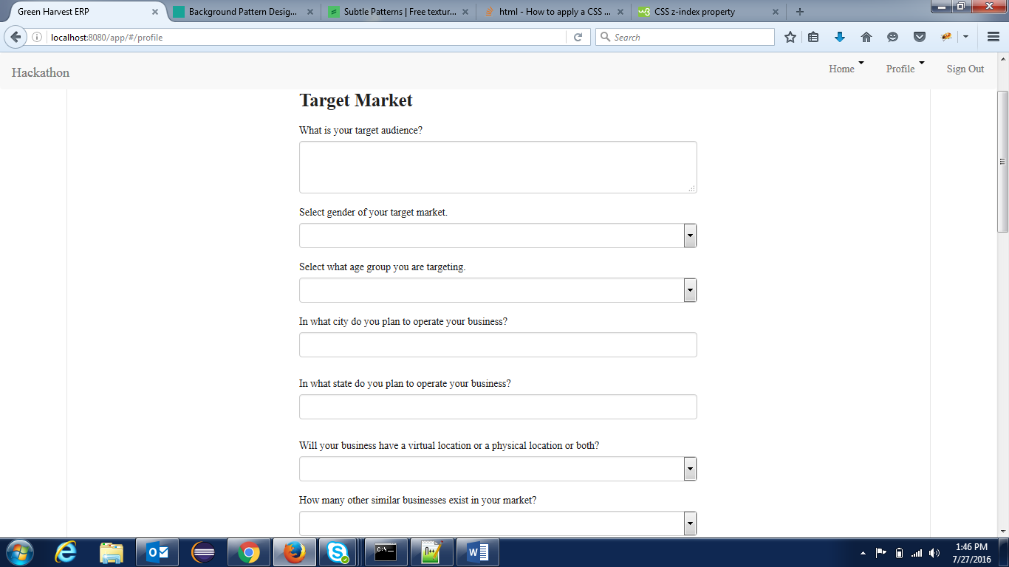

Information on Target Market inputs:

Target Audience: Long text input

Gender: Drop down list

Age Group: Drop down list

City: Short text input

State: Long text input

Location Type: Drop down list

Number of Competing Businesses: Drop down list

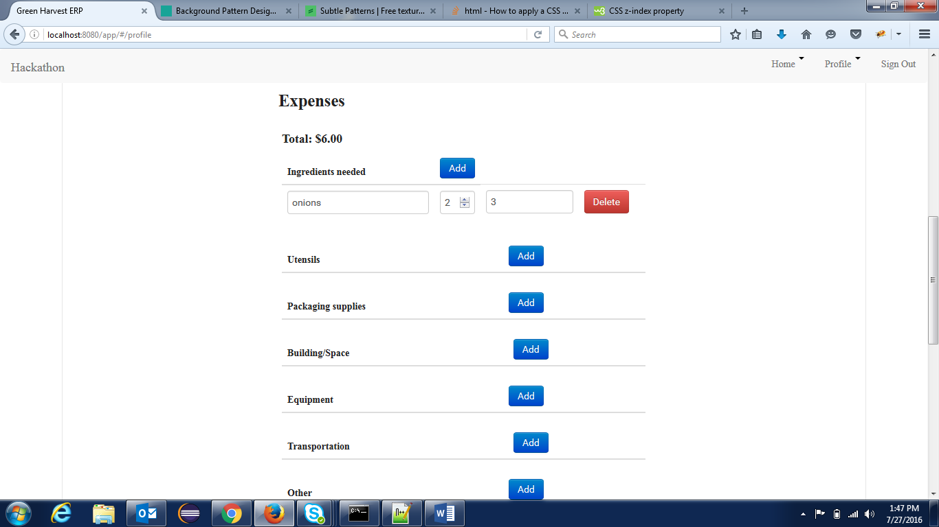

Information on Expenses:

Items: Short text input

Quantity: Number input

Price: Number input

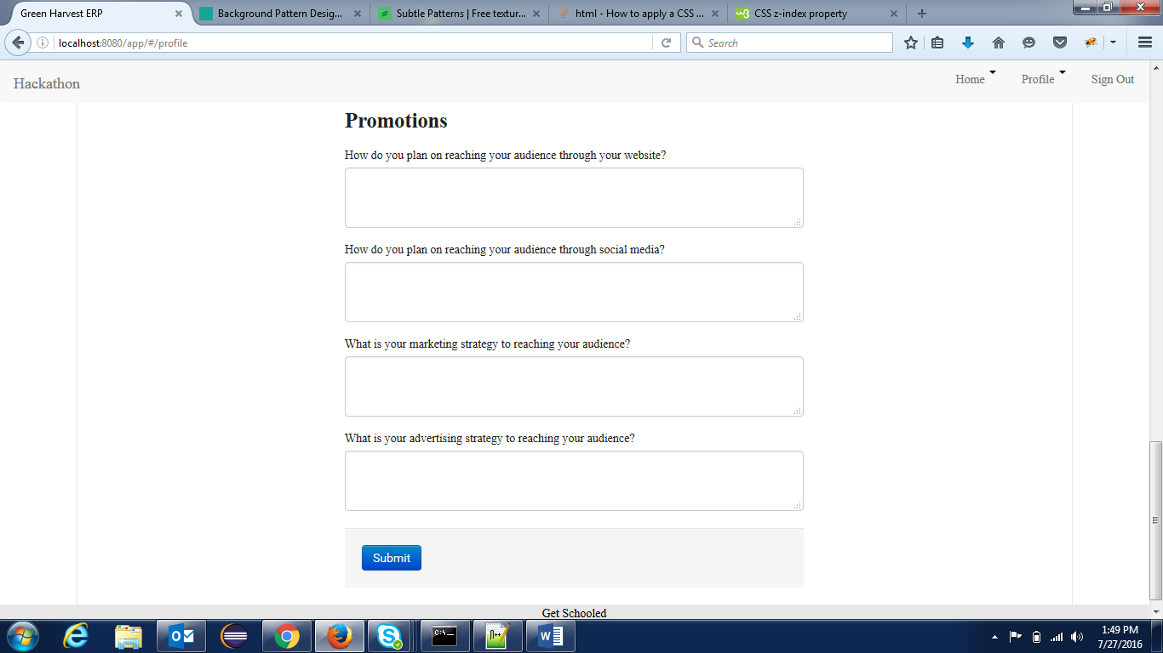

Information on Promotions Inputs:

Website Outreach: Long text input

Social Media Outreach: Long text input

Marketing Strategy: Long text input

Advertising Strategy: Long text input

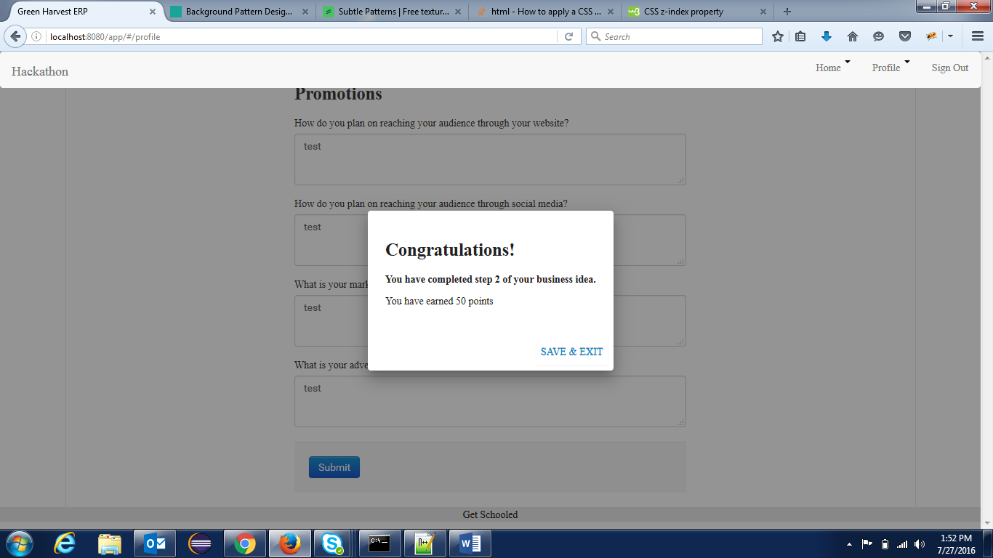

The business proposal will be added to the list on the home screen.

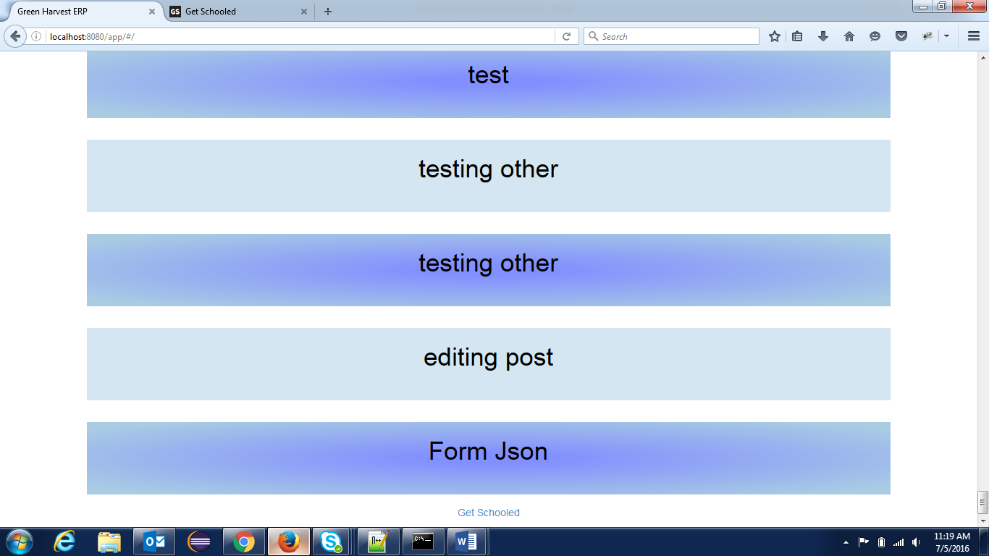

The business proposal can be viewed from this page directly.

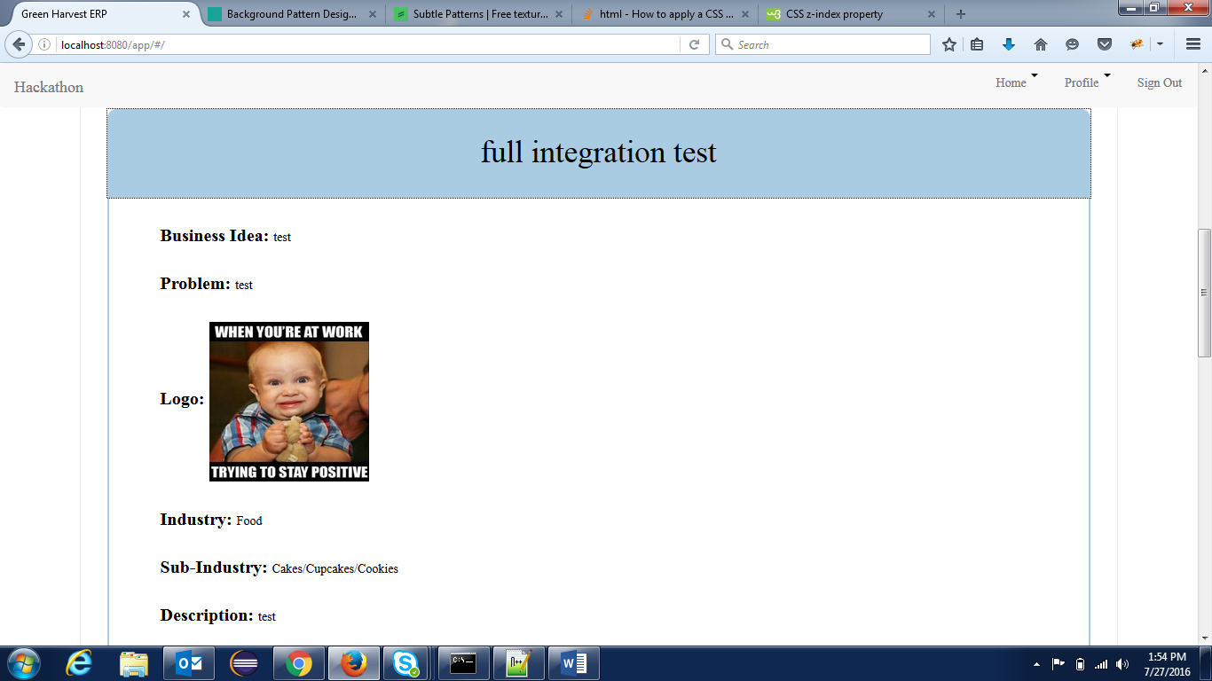

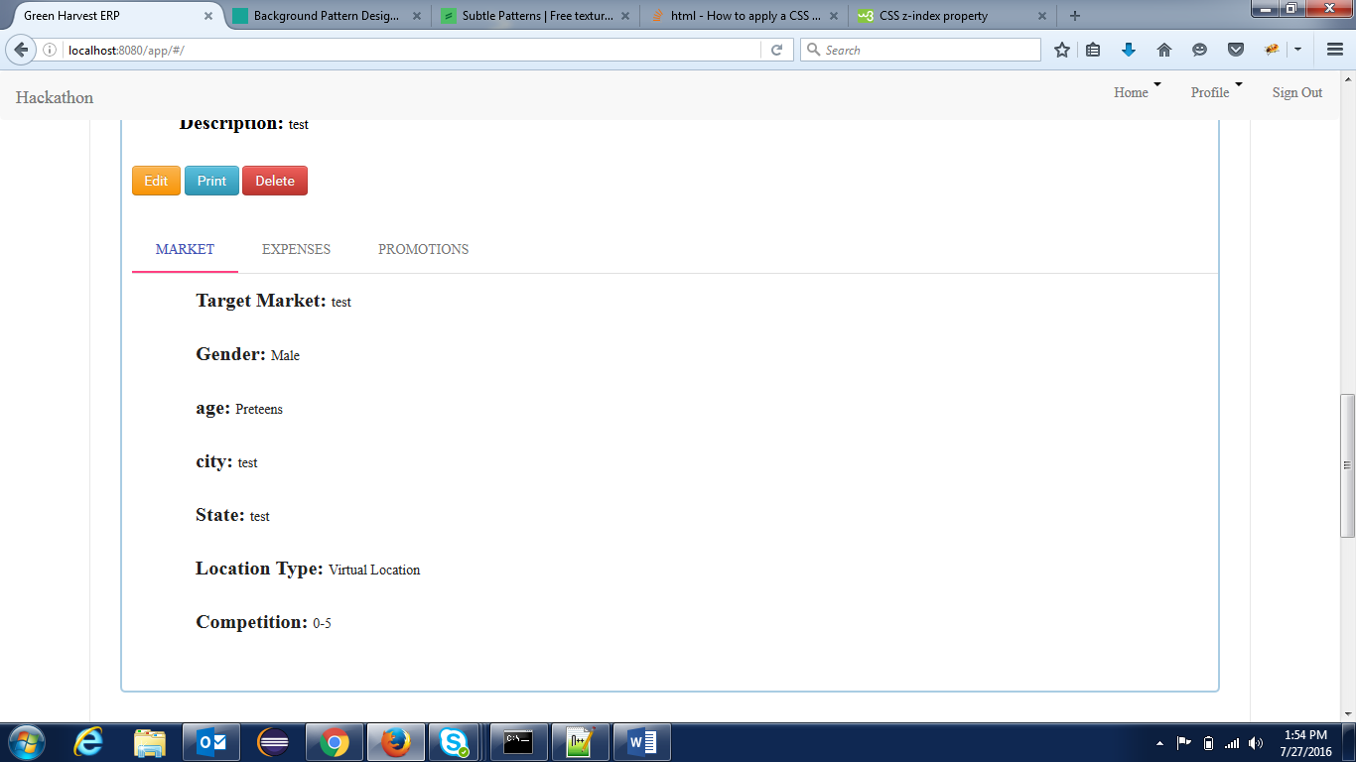

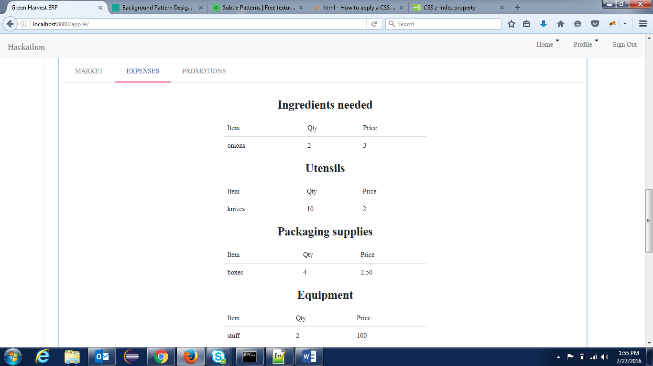

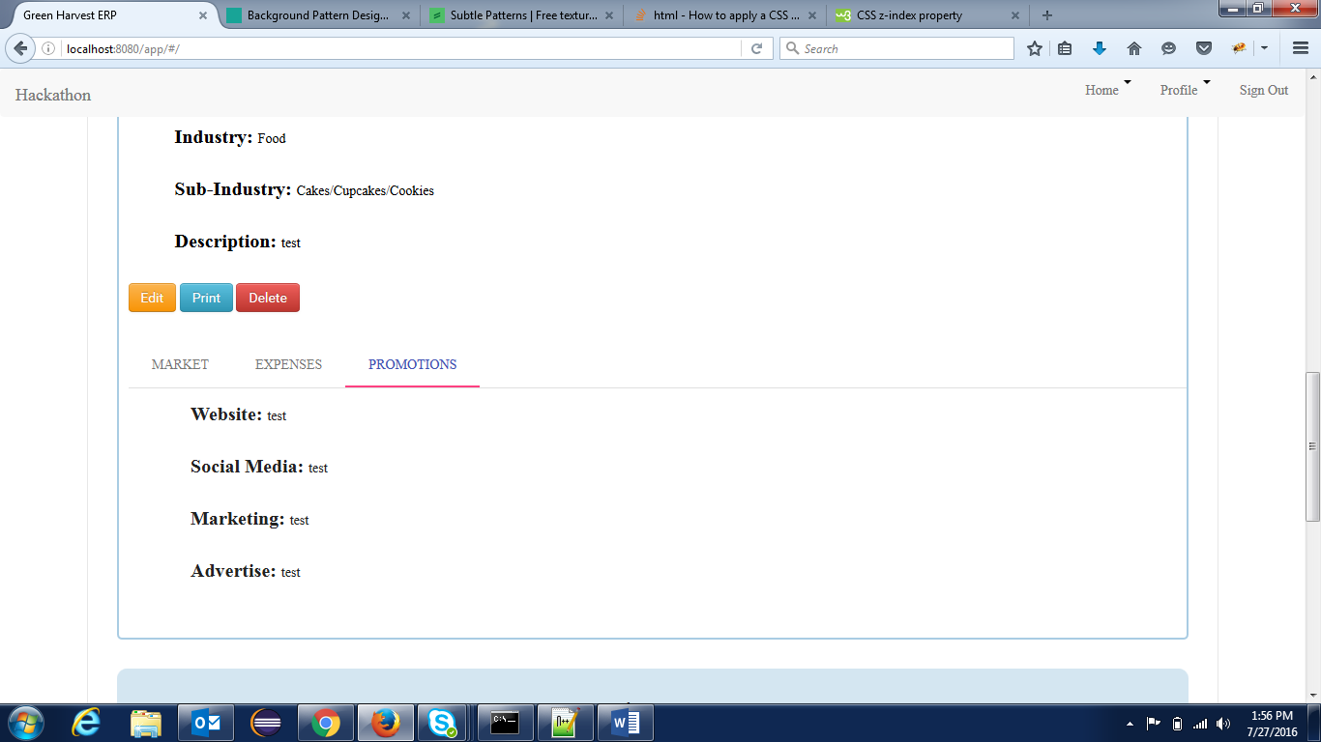

1. **Editing a Business Proposal**

After submitting a proposal, the user will be able to edit the post directly from the home page from clicking the edit button.

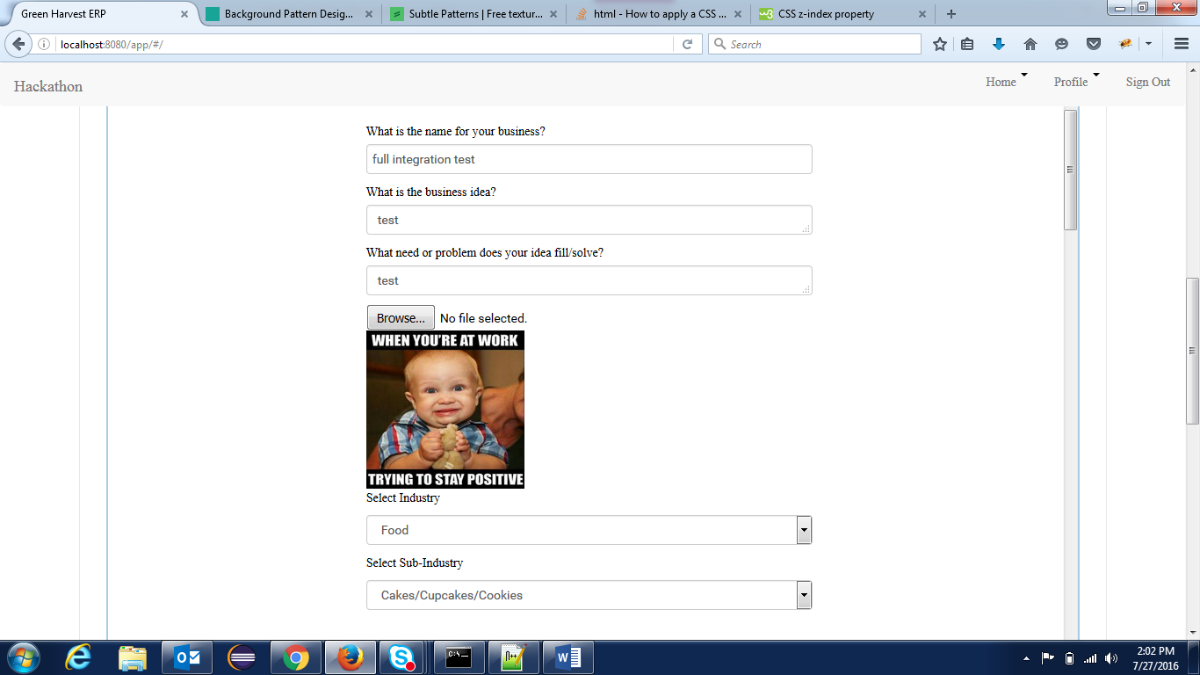

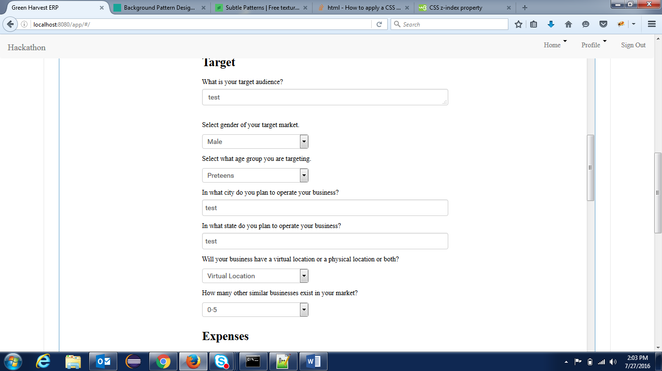

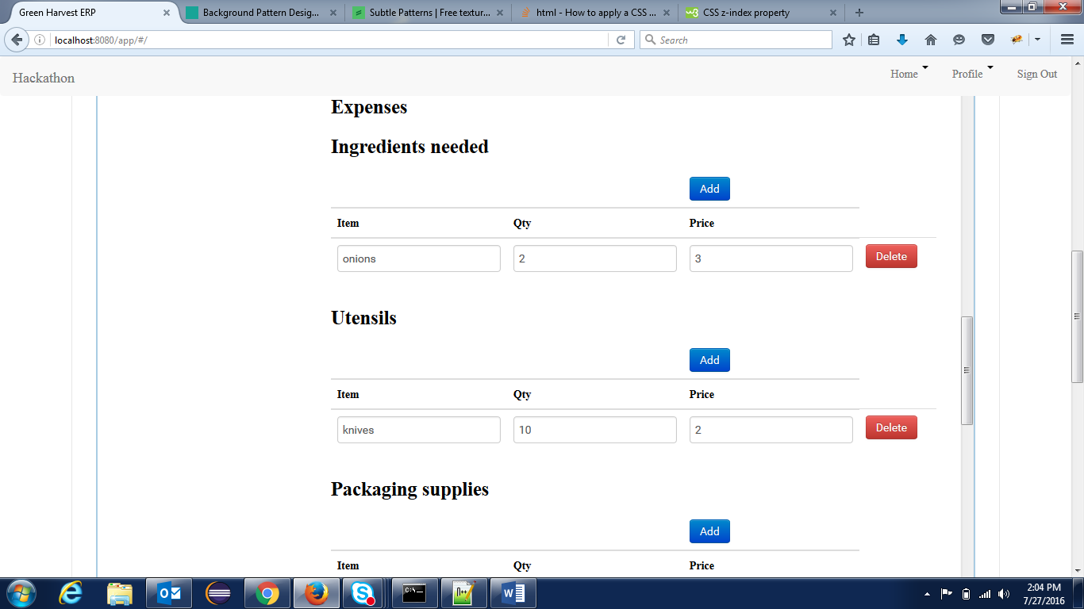

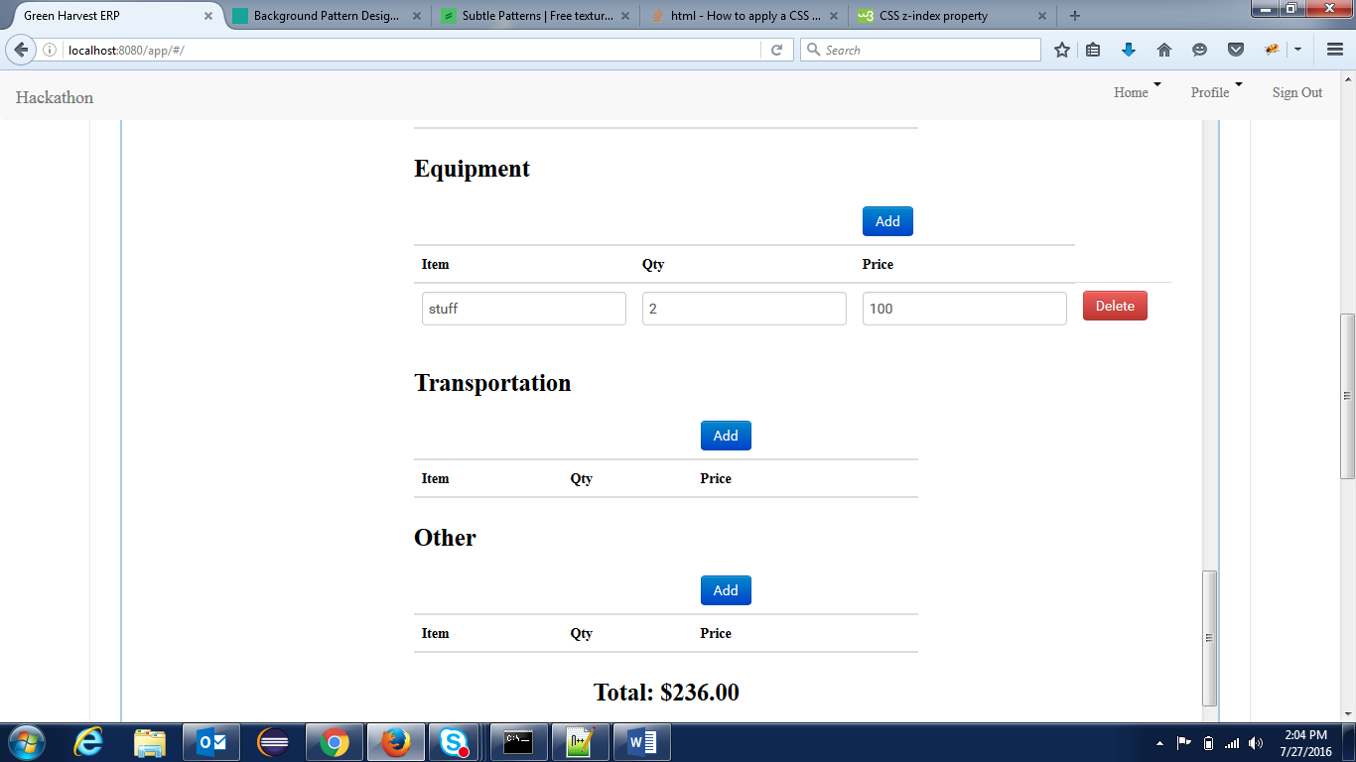

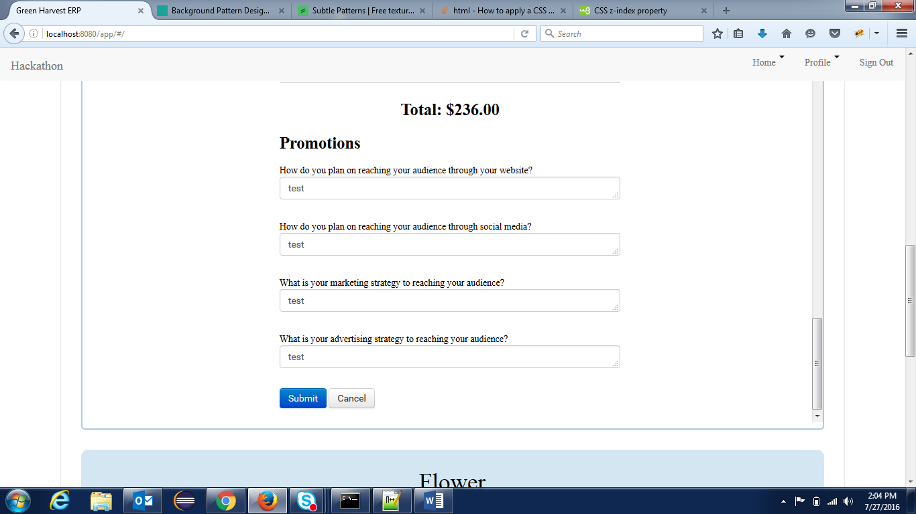

Make your changes and send the update with the submission button. The user can also select the “Cancel” button to cancel the update.

1. **Deleting a Business Proposal**

The user will also have the opportunity to delete business proposals from the home page by selecting the “Delete” button as pictured below.

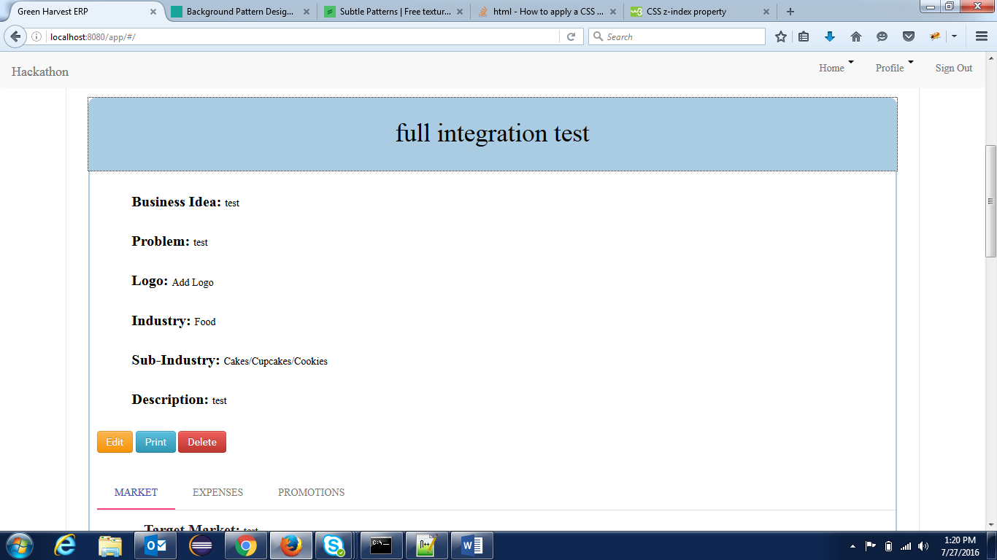

A popup window will confirm whether you intend to delete the business proposal or not.

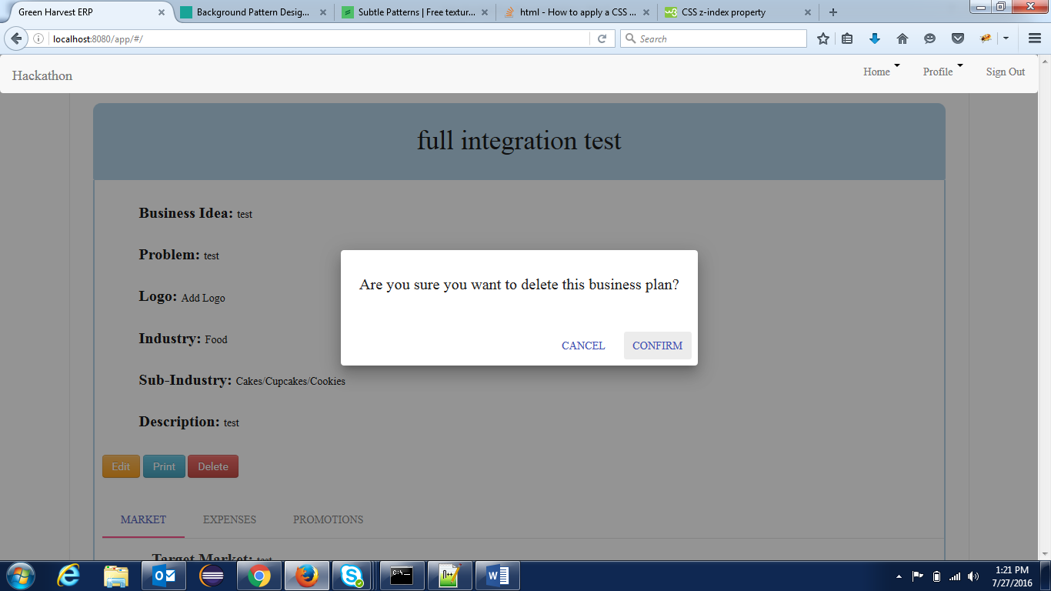

Confirm will delete the post, while cancel will leave the post in place.

1. **Printing a business proposal**

You can also get a printable version of the business idea by clicking the “Print” button on the business posting.

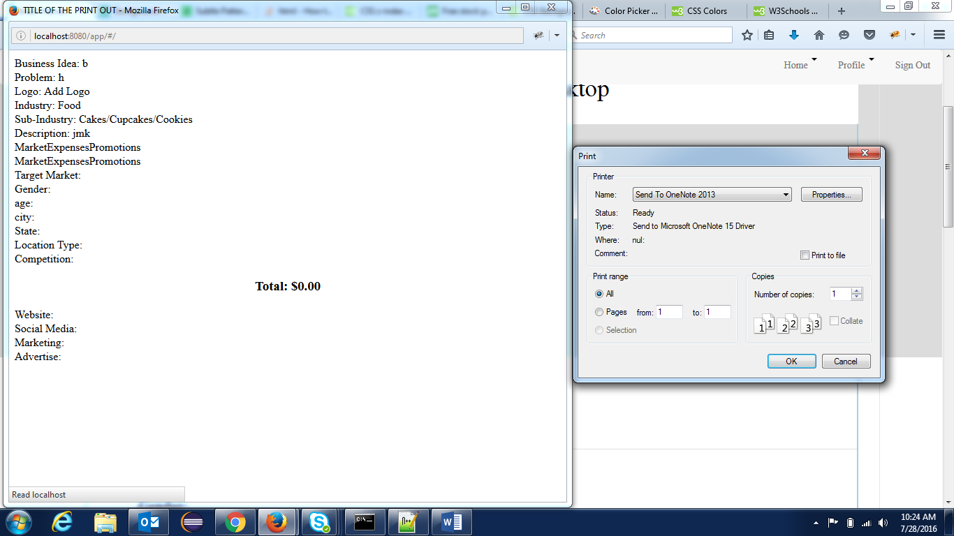

**Technologies Used**

1. AngularJS
2. JQuery/JavaScript
3. HTML5
4. CSS3